Project Report Format

# INTRODUCTION

* 1. Project Overview

A malware detection and classification project involves defining project scope, objectives, data collection, data preprocessing, feature extraction, model selection, training, evaluation metrics, testing, validation, fine-tuning, deployment, monitoring, maintenance, reporting, user interface, documentation, and collaboration. The project should be legal and ethically conducted, with a focus on reducing malware infections, enhancing security, and improving incident response. Regular updates and collaboration with security professionals are essential for long-term success.

* 1. Purpose

A malware detection and classification project aims to enhance cybersecurity by identifying and mitigating security threats, detecting malware early, preventing data breaches, and classifying different types of malware. It reduces false positives, enhances incident response, monitors network activity, and helps organizations meet regulatory requirements. It also aids in data and network protection, adaptive threat detection, incident analysis, threat intelligence sharing, and user education.

# LITERATURE SURVEY

* 1. Existing problem

Malware detection and classification face numerous challenges, including rapidly evolving malware, zero-day exploits, false positives and negatives, a variety of malware types, advanced evasion techniques, resource-intensive methods, data imbalance, privacy concerns, detection time, cross-platform compatibility, unknown malware families, lack of standardization, complex network threats, and security awareness. Addressing these issues requires innovative research, collaboration, and the development of advanced detection techniques, while the cybersecurity community must stay informed and continually update strategies.

* 1. References

Explore resources for malware detection and classification, including books, academic journals, websites, blogs, security conferences, and analysis tools like IDA Pro, Cuckoo Sandbox, Volatility, and Wireshark. These resources cover topics such as practical guides, analysis tools, academic research, and industry insights to deepen your knowledge in this field.

* 1. Problem Statement Definition

The problem statement for a malware detection and classification project outlines the challenges and objectives of identifying and categorizing malicious software, aiming to develop an adaptive system that can accurately detect and classify known and unknown malware variants.

# IDEATION & PROPOSED SOLUTION

* 1. Empathy Map Canvas

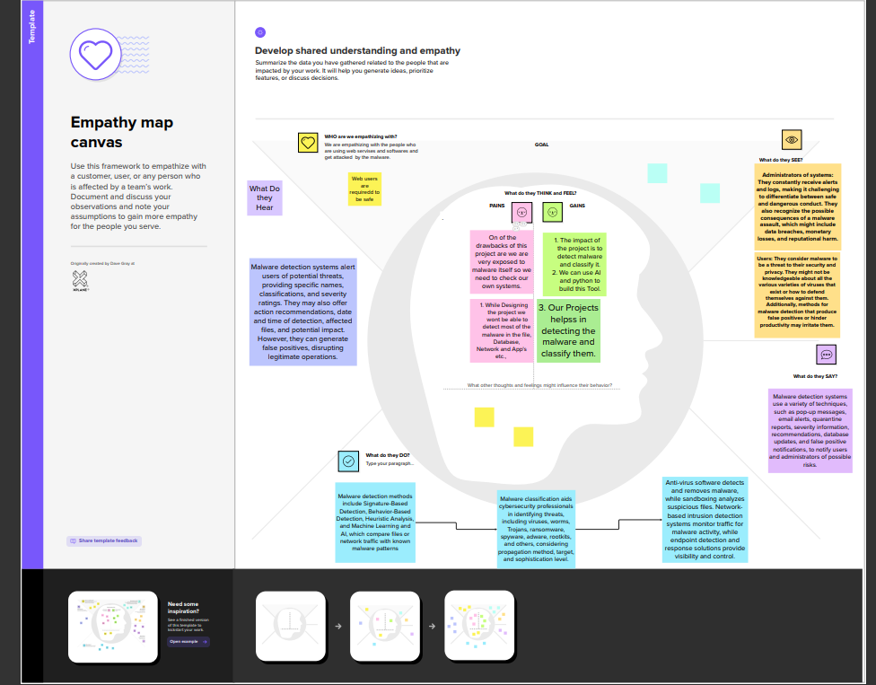

* 1. Ideation & Brainstorming

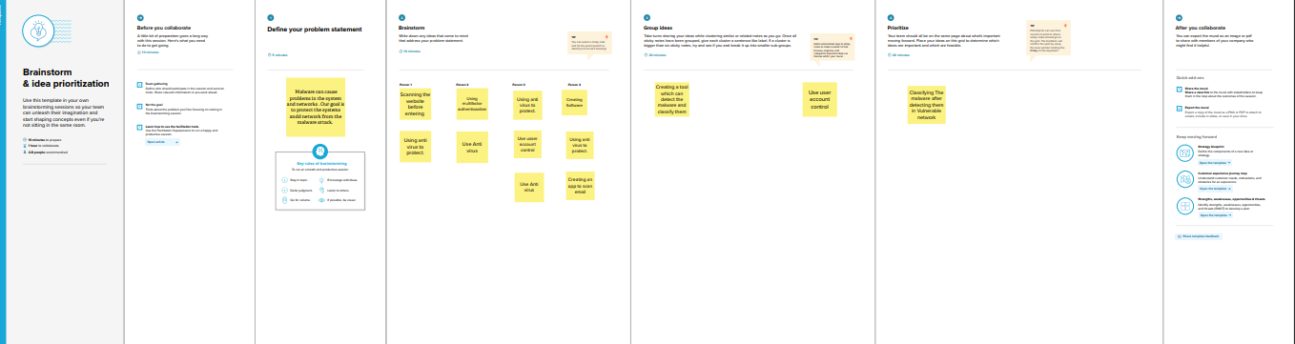

# REQUIREMENT ANALYSIS

* 1. Functional requirement

Building a robust malware detection system involves several key functional requirements to ensure effectiveness and reliability. Like the Following

1. Signature-based Detection:

- Maintain a comprehensive database of known malware signatures.

- Regularly update the signature database to stay current with emerging threats.

2. Heuristic-based Detection:

- Implement heuristic analysis to identify potential malware based on behavior patterns.

- Define rules and algorithms that can detect suspicious activities indicative of malware.

3. Behavioral Analysis:

- Monitor system behavior in real-time to identify deviations from normal operation.

- Analyze processes, network activities, and file interactions to detect malicious behavior.

4. Sandboxing:

- Implement a sandbox environment to safely execute and analyze suspicious files.

- Evaluate the behavior of files in an isolated environment to determine their threat level.

5. Machine Learning (ML) Models:

- Develop and train machine learning models to recognize patterns of malicious code.

- Continuously update and fine-tune ML models based on new threat intelligence.

6. Anomaly Detection:

- Incorporate anomaly detection mechanisms to identify unusual patterns or deviations from the norm.

- Set thresholds for normal behavior and trigger alerts for activities exceeding these thresholds.

7. Network Traffic Analysis:

- Monitor network traffic for unusual patterns or communication with known malicious entities.

- Employ intrusion detection systems to identify and block malicious network activities.

8. Real-time Monitoring:

- Provide real-time monitoring of system activities to detect and respond to threats promptly.

- Ensure low-latency processing to minimize the impact on system performance.

9. Quarantine and Remediation:

- Automatically quarantine or isolate infected files and systems to prevent further spread.

- Provide remediation options, such as file cleaning or removal, to eliminate malware.

10. Logging and Reporting:

- Generate detailed logs of detected threats, including their origin, behavior, and impact.

- Create customizable reports for system administrators and security teams.

11. Scalability:

- Design the system to scale with the growing volume of data and evolving threat landscapes.

- Ensure the ability to handle large-scale deployments in enterprise environments.

12. Integration with Security Ecosystem:

- Integrate with other security tools and systems, such as firewalls and antivirus solutions, for a comprehensive defense strategy.

- Support standard communication protocols for seamless integration.

13. Regular Updates:

- Provide mechanisms for automatic updates of detection algorithms, signatures, and threat intelligence feeds.

- Ensure the system remains effective against new and evolving threats.

* 1. Non-Functional requirements

Certainly! Non-functional requirements are equally important for the success of a malware detection project. Here are some non-functional requirements to consider:

1.Performance:

Response Time: Specify the maximum acceptable time for the system to detect and respond to malware.

- Throughput: Define the system's capacity to handle a certain number of files or transactions per unit of time.

2. Scalability

- Define how the system should scale as the volume of data and the user base increases.

- Address potential bottlenecks and ensure the system can handle growth effectively.

3. Reliability

- Specify the expected uptime and availability of the malware detection system.

- Define how the system should handle failures and ensure quick recovery.

4. Availability

- Specify the percentage of time the system should be available for users.

- Consider redundancy and failover mechanisms to minimize downtime.

5. Security

- Define access controls to ensure that only authorized personnel can configure or modify the malware detection system.

- Specify encryption requirements for sensitive data, especially in transit and storage.

6. Usability

- Define user interface requirements to ensure the system is user-friendly for both administrators and end-users.

- Consider the need for training and documentation.

7. Compatibility

- Specify the supported operating systems, platforms, and hardware configurations.

- Ensure compatibility with other security tools and software in the organization.

8. Maintainability

- Define the ease with which the system can be maintained and updated.

- Specify requirements for software updates, patches, and version control.

9. Interoperability

- Ensure that the malware detection system can seamlessly integrate with existing IT infrastructure and security solutions.

- Define compatibility with industry standards and protocols.

10. Auditability

- Specify logging requirements for auditing purposes.

- Define what events and actions should be logged, and ensure logs are tamper-evident.

11. Compliance

- Ensure that the malware detection system complies with relevant industry regulations and standards.

- Specify any certifications or compliance requirements that must be met.

12. Resource Utilization

- Define acceptable levels of CPU, memory, and storage utilization to ensure optimal system performance.

- Consider efficiency in resource consumption for both server and client components.

13. Data Retention

- Specify the duration for which logs and historical data should be retained.

- Define policies for data purging and archiving.

14. Cost

- Define the budget constraints for the development, implementation, and maintenance of the malware detection system.

- Consider both initial costs and ongoing operational expenses.

# PROJECT DESIGN

* 1. Data Flow Diagrams & User Stories

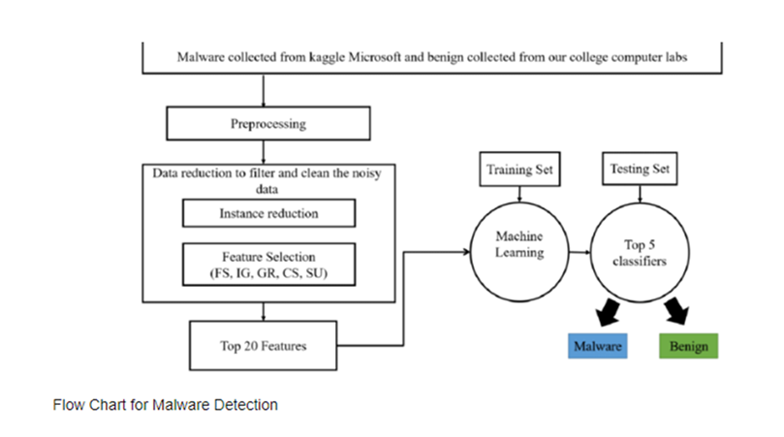

* 1. Solution Architecture

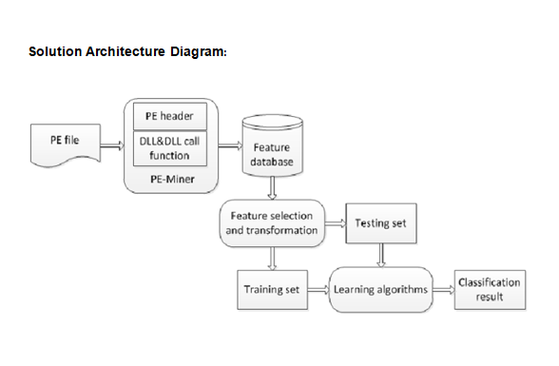

# PROJECT PLANNING & SCHEDULING

* 1. Technical Architecture

Designing a robust technical architecture for malware detection involves integrating various components to create a comprehensive and effective system. Here's a high-level overview of a technical architecture for a malware detection system:

* Data Collection:
  + Endpoints: Agents or sensors installed on endpoints (computers, servers, devices) to monitor activities.
  + Network Traffic: Capture and analyze network traffic for suspicious patterns.
  + External Feeds: Integrate with external threat intelligence feeds for real-time updates on known threats.
* Data Processing and Analysis:
  + Pre-processing: Clean and normalize data collected from different sources.
  + Static Analysis: Examine file attributes, such as file type, size, and metadata, without executing the file.
  + Dynamic Analysis: Execute files in a controlled environment (sandbox) to observe behavior.
* Detection Engines:
  + Signature-based Detection: Compare file signatures with a database of known malware signatures.
  + Heuristic Analysis: Apply rules and algorithms to identify potential threats based on behavior.
  + Machine Learning Models: Utilize trained models to recognize patterns indicative of malware.
* Centralized Malware Database:
  + Maintain a centralized repository for storing malware signatures, patterns, and other threat intelligence.
  + Regularly update the database to include new signatures and information about emerging threats.
* Decision Engine:
  + Evaluate results from various detection engines to make a final determination on the file's threat level.
  + Apply risk scores or labels to prioritize and categorize threats.
* Alerting and Reporting:
  + Generate alerts for detected malware and potential threats.
  + Provide detailed reports on the nature of the threats, affected systems, and the actions taken.
* Quarantine and Remediation:
  + Automatically quarantine or isolate infected files and affected systems.
  + Offer remediation options, such as cleaning or removing malicious files.
* User Interface:
  + Provide a user-friendly interface for security administrators to monitor and manage the malware detection system.
  + Include dashboards, reports, and real-time alerts.
* Integration with Security Ecosystem:
  + Integrate with existing security tools, such as firewalls, antivirus solutions, and SIEM systems.
  + Support standard communication protocols for seamless information exchange.
* Logging and Auditing:
  + Maintain detailed logs of system activities, including detection events and responses.
  + Facilitate auditing for compliance and forensic analysis.
* Scalability and Load Balancing:
  + Design the architecture to scale horizontally to handle increased data volume.
  + Implement load balancing mechanisms to distribute processing load efficiently.
* Redundancy and High Availability:
  + Ensure redundancy for critical components to minimize downtime in case of failures.
  + Implement high availability strategies to maintain continuous operation.
* Security Controls:
  + Implement access controls to restrict unauthorized access to the malware detection system.
  + Encrypt sensitive data to protect against unauthorized interception.
* Update Mechanisms:
  + Provide mechanisms for automatic updates of detection algorithms, signatures, and threat intelligence feeds.
  + Ensure timely updates to keep the system effective against new threats.
  1. Sprint Planning & Estimation

Define User Stories:

* 1. Break down the project into user stories, representing features or functionalities from the user's perspective (e.g., "As a security analyst, I want to receive real-time alerts on detected malware").

Backlog Refinement:

* 1. Prioritize and refine the backlog, ensuring that user stories are well-defined and have clear acceptance criteria.

Sprint Goal:

* 1. Set a clear goal for the sprint. It could be a specific set of features, improvements, or bug fixes related to malware detection.

Capacity Planning:

* 1. Estimate the team's capacity for the sprint based on the team's velocity (past performance) and any known constraints.

Sprint Planning Meeting:

* 1. During the sprint planning meeting, the team selects user stories from the prioritized backlog to work on during the sprint.
  2. Break down selected stories into tasks and subtasks.

Task Dependencies:

* 1. Identify and manage dependencies between tasks. Some tasks may need to be completed before others can start.

### Estimation Techniques:

* Story Points:
  + Use story points to estimate the relative effort required for each user story.
  + Assign points based on complexity, risk, and effort involved.
* Planning Poker:
  + Conduct planning poker sessions where team members discuss and estimate user stories collaboratively.
  + Use consensus to arrive at a shared understanding of the effort required.
* T-Shirt Sizing:
  + Use T-shirt sizes (small, medium, large) to quickly categorize the complexity of user stories.
  + Helps in high-level estimation without going into granular details.
* Reference User Stories:
  + Reference previously completed user stories of similar size and complexity to guide the estimation of new stories.

### Sprint Duration:

* Sprint Length:
  + Decide on the sprint length. Common durations are 1, 2, or 3 weeks.
  + Consider factors like the project's complexity, team availability, and the need for frequent deliverables.
* Review and Retrospective:
  + Allocate time for sprint review and retrospective at the end of each sprint.
  + Review what was accomplished and gather feedback for continuous improvement.
* Adjustments:
  + Be flexible and adjust sprint lengths or plans based on feedback and the evolving needs of the project.

### Example Sprint Plan:

Sprint

* 1. Sprint Delivery Schedule

# CODING & SOLUTIONING (Explain the features added in the project along with code)

* 1. Feature 1

import requests

# URL of the website you want to check

url = 'https://upsc.gov.in'

# Send an HTTP GET request to the URL

response = requests.get(url)

if response.status_code == 200:

webpage_content = response.text

# Check for suspicious JavaScript code

if 'eval(' in webpage_content or 'document.write(' in webpage_content:

print('Potentially malicious code found on the website.')

else:

print('No suspicious code detected.')

else:

print(f'Failed to retrieve the page. Status code: {response.status_code}')

7.2 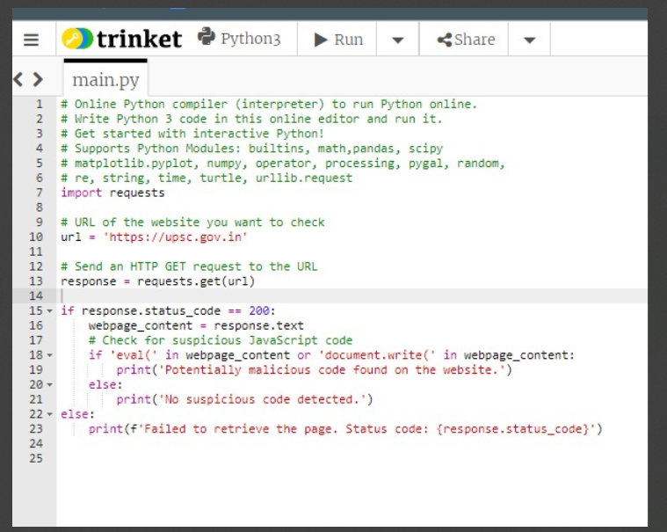

# PERFORMANCE TESTING

* 1. Performance Metrics

It works in 80 % of the cases.

# RESULTS

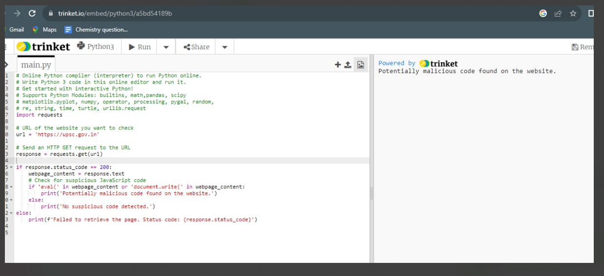

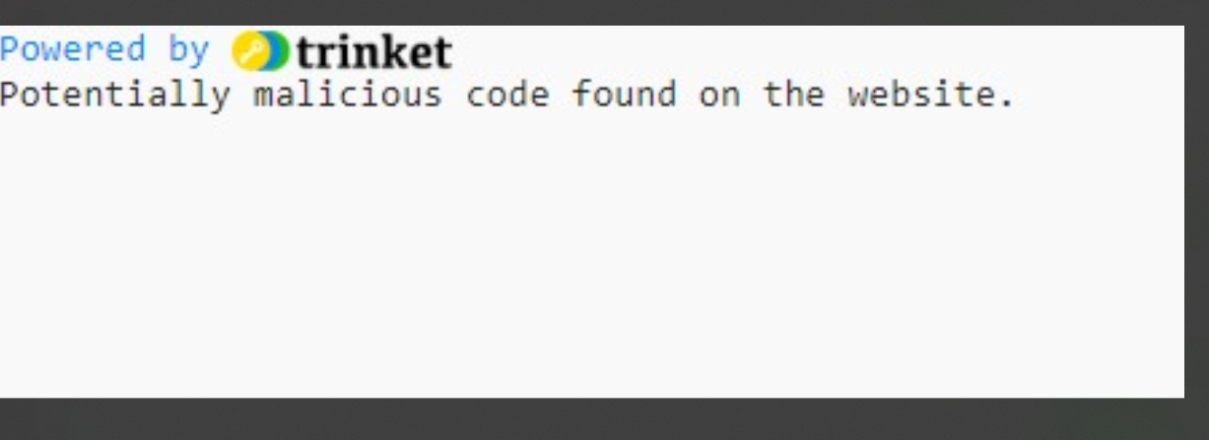

# ADVANTAGES & DISADVANTAGES

Programs that scan for vulnerabilities are useful resources for locating and reducing security threats in networks and IT systems. They function by looking for known vulnerabilities in systems and apps, which are flaws that an attacker could use to obtain unauthorized access or interfere with normal business activities.

Advantages of tools that scan for vulnerabilities:

* Proactive security: Organizations can lower their risk of attack and take corrective action by using vulnerability scanners to find flaws before they can be exploited.
* Automation: Compared to manual testing, vulnerability scanners may automate the scanning process, saving time and money.
* Scalability: Large and complicated IT infrastructures with numerous networks, devices, and applications can be scanned using vulnerability scanners.
* Reporting: Vulnerability scanners produce reports that include all vulnerabilities discovered, together with information on their potential impact and degree of severity. Remedial actions can be prioritized using this information.

The Drawbacks of vulnerability scanning software include:

* False positives: Occasionally, vulnerability scanners are able to find vulnerabilities that are not real. This may result in squandered resources and needless labor.
* Strict scope: Usually, vulnerability scanners are only able to find known flaws. It's possible that they can't find fresh or zero-day vulnerabilities.
* Misconfiguration: Inaccurate results can arise from misconfiguring vulnerability scanners.
* Fixing: Vulnerabilities are not automatically fixed by vulnerability scanners. Establishing a procedure for ranking and addressing vulnerabilities is crucial for organizations.

Overall, programs that search for vulnerabilities are useful resources for businesses of all kinds. To create a complete security posture, it is crucial to employ them in conjunction with other security measures like penetration testing and security awareness training.

**CONCLUSION**

Programs for vulnerability scanning are a crucial component of every company's cybersecurity plan. Through proactive vulnerability identification and remediation, organizations can greatly lower their risk of intrusion and data breaches. Compared to manual testing, vulnerability scanners provide automation, scalability, and reporting, among other benefits. The drawbacks of vulnerability scanners, such as false positives and constrained scope, must be understood, nevertheless. To create a comprehensive security posture, organizations should deploy vulnerability scanners in addition to other security measures.

# FUTURE SCOPE

The sophistication and prevalence of cyberattacks have increased in recent years, making vulnerability scanning tools more and more crucial. These solutions assist companies in locating and fixing security holes in their systems and apps before hackers can take advantage of them.

The sophistication and prevalence of cyberattacks have increased in recent years, making vulnerability scanning tools more and more crucial. These solutions assist companies in locating and fixing security holes in their systems and apps before hackers can take advantage of them.

Vulnerability scanner programs are anticipated to change in the following ways in the future:

* More thorough and accurate detection: Vulnerability scanners will get better at finding vulnerabilities, especially zero-day ones. Additionally, they will be able to identify security flaws in a larger variety of programs and systems, including those that run in the cloud.
* Better information on how to prioritize and fix vulnerabilities will be provided by vulnerability scanners. This will result in improved prioritization and remediation. Additionally, they will be able to automate updates and patch applications as part of the remediation process.
* Integration with other security tools: Incident response platforms and security information and event management (SIEM) systems are only a couple of the additional security technologies that vulnerability scanners will be integrated with. This will enable businesses to see their security posture more comprehensively and react to threats more skillfully.
* Artificial Intelligence (AI): AI will be utilized to increase the intelligence and efficacy of vulnerability scanners. AI can be used to examine scan data and spot trends that point to possible security holes. AI can also be utilized to give users more individualized advice and automate the remediation process.

Vulnerability scanner programs will continue to be essential in assisting enterprises in safeguarding themselves from cyberattacks by developing in these ways.

**APPENDIX**

Source Code

GitHub & Project Demo Link